Project Design Phase-II
Technology Stack (Architecture & Stack)

Date | 21 February 2026
Team ID | LTVIP2006TMIDS88079
Project Name | An In-Depth Analysis Of UNESCO World Heritage Sites In Tableau
Maximum Marks | 4 Marks

Technical Architecture:
The Deliverable shall include the architectural diagram as below and the information as per the table1 & table 2

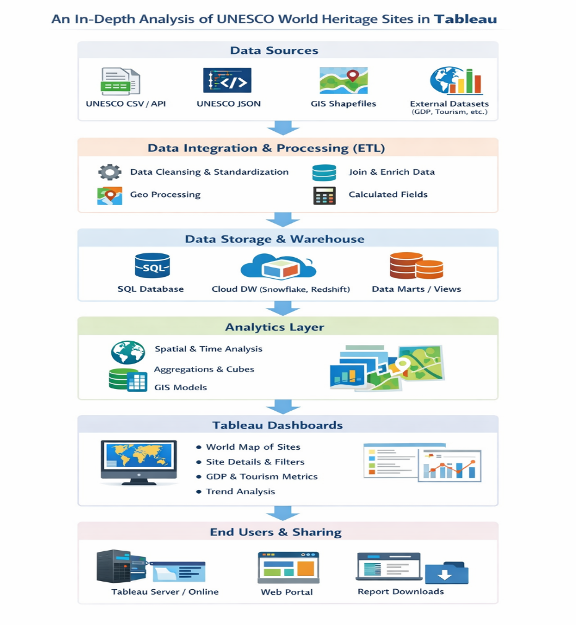

Technology Stack
Below is the technology stack used in the UNESCO World Heritage Sites Tableau project.

Table-1: System Component
Sno | Components | Description | Technology
1 | User Interface | How users interact with the UNESCO World Heritage analytics dashboard (Web Dashboard, Interactive Map View, Mobile-responsive interface) | HTML, CSS, JavaScript / Angular JS / React JS
2 | Data Integration Layer | Connects and imports UNESCO World Heritage datasets including country, region, category (Cultural/Natural/Mixed), year of inscription, and risk status | Python, Tableau
3 | Data Preparation & Transformation | Cleans and formats raw UNESCO datasets (handling missing values, standardizing country names, site categories, and inscription years) | Tableau Prep, Python (Pandas, NumPy)
4 | Analytics & Visualization Engine | Creates maps, bar charts, time-series analysis, category comparisons, and geographical distribution dashboards | Tableau Desktop
5 | Calculated Metrics & Business Logic | Computes KPIs such as Total Sites by Country, Sites by Category %, Growth Trend by Year, Sites at Risk %, Regional Distribution | Tableau Calculated Fields, Python
6 | Database | Stores structured UNESCO site data, regional classifications, and processed extracts | MySQL / PostgreSQL / CSV Data Sources
7 | Cloud & File Storage | Stores datasets, dashboard files, and project documentation for collaboration | Google Drive / AWS S3 / Local Storage
8 | Dashboard Publishing Platform | Publishes dashboards for academic review, research presentation, and stakeholder access | Tableau Public / Tableau Server / Tableau Cloud
9 | External Data Sources | Integrates supplementary datasets such as global tourism statistics, population data, and geographic shapefiles | Open Data APIs / CSV datasets
10 | Performance Optimization | Improves dashboard loading speed and responsiveness for large geographic datasets | Tableau Extracts (.hyper), Data Aggregation
11 | Infrastructure & Deployment | Hosts dashboards for online access and ensures high availability | Local Server / Cloud Hosting

Table-2: Application Characteristics
S.No | Category | Description | Technology Used
1 | Open-Source Frameworks | Libraries used for data cleaning, transformation, statistical analysis, and trend forecasting of UNESCO site distribution | Python, Pandas, NumPy, Scikit-Learn
2 | Security Implementations | Authentication and access control to ensure secure sharing of dashboards and datasets | Role-Based Access Control (RBAC), OAuth 2.0
3 | Scalable Architecture | System design supports addition of new UNESCO sites, updated yearly inscriptions, and extended geographic datasets | Cloud Storage, REST APIs
4 | Availability | Ensures dashboards are accessible for academic presentations, research discussions, and online publication | Tableau Server Deployment / Tableau Cloud Hosting
5 | Performance | Optimized extracts and filtering for smooth interaction with map-based visualizations | Tableau Extracts (.hyper), Indexed Queries
6 | Data Accuracy | Validation of UNESCO site counts, categories, and inscription years against official data sources before publishing | Data Validation Scripts (Python)
7 | Usability | Clean dashboard layout with interactive world maps, category filters, region selectors, and intuitive legends | Tableau Design Principles
8 | Reliability | Handles missing geographic coordinates, incomplete site records, or inconsistent country names without errors | Error Handling in Python, Data Cleaning Logic

